**Ideation Phase**

**Brainstorm & Idea Prioritization Template**

|  |  |
| --- | --- |
| Date | 18May2023 |
| Team ID | PBL-NT-GP-9119-1682672259 |
| Project Name | Automatic weather classification using transfer learning |
| Maximum Mark | 4 Marks |

**Step-1: Team Gathering, Collaboration and Select the Problem Statement**

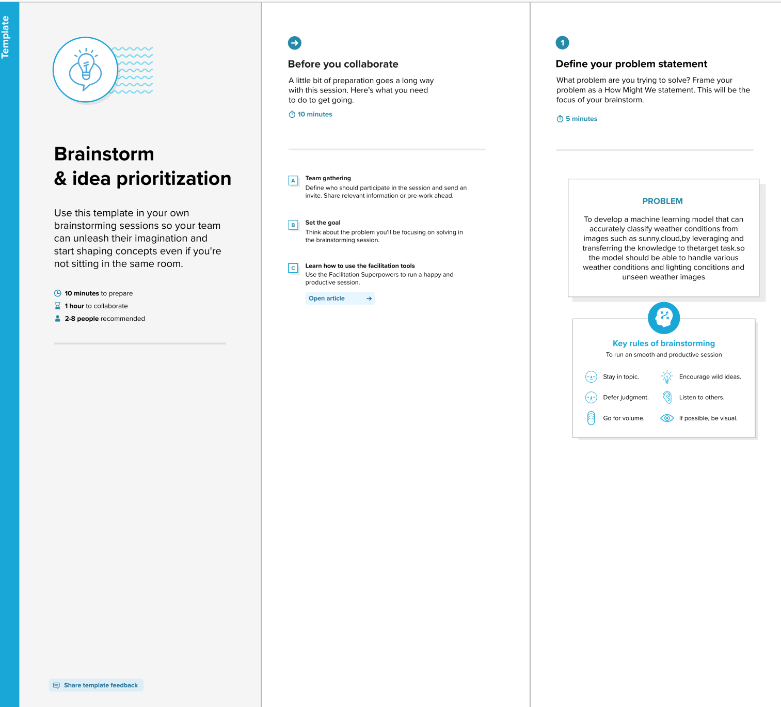

**Step-2: Brainstorm, Idea Listing and Grouping**

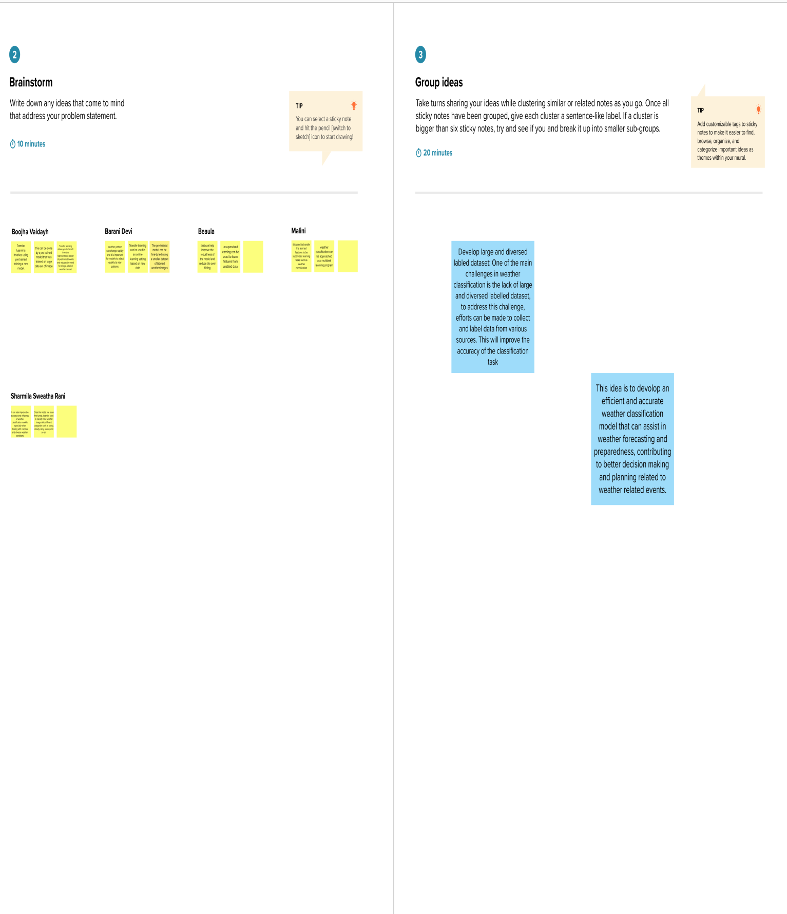**Step-3: Idea Prioritization**

